Commercial Test Weight
# Source: AI Source: Provided by: [Data Path: Persons Table -> ID Column: 1, Name_En Column: Motasem Essam] -> From: [ChatGPT] on [7/17/2026]
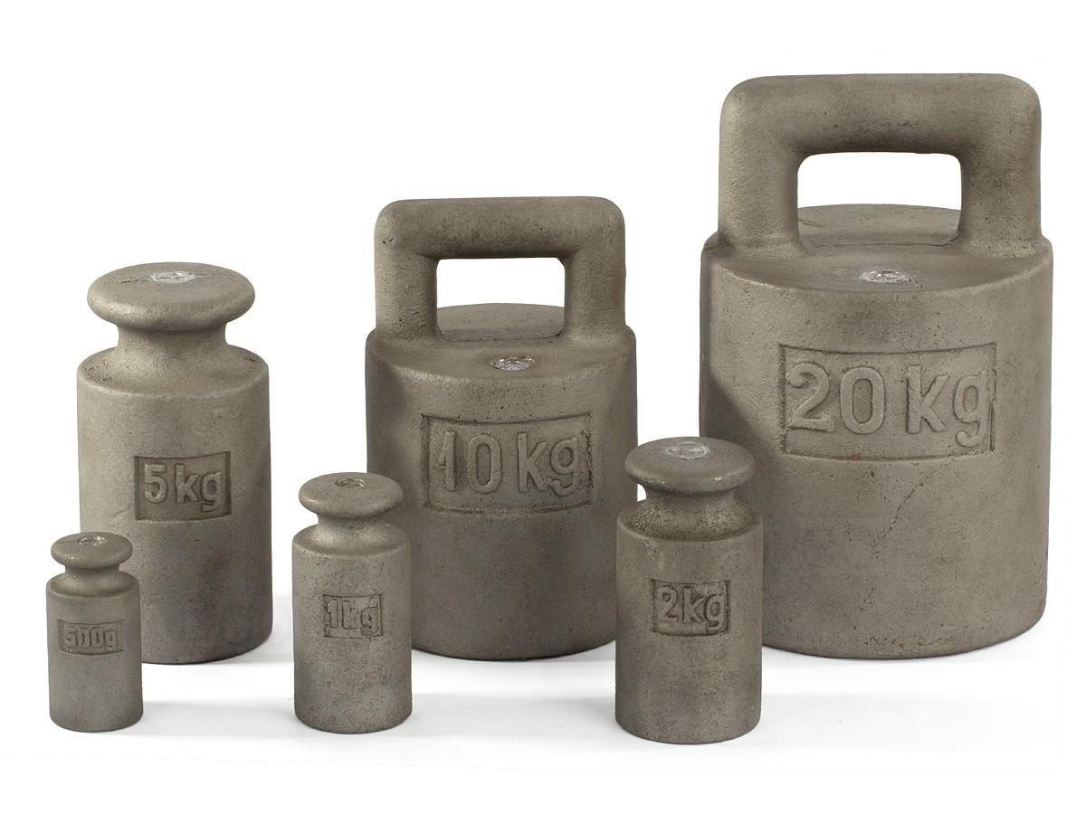
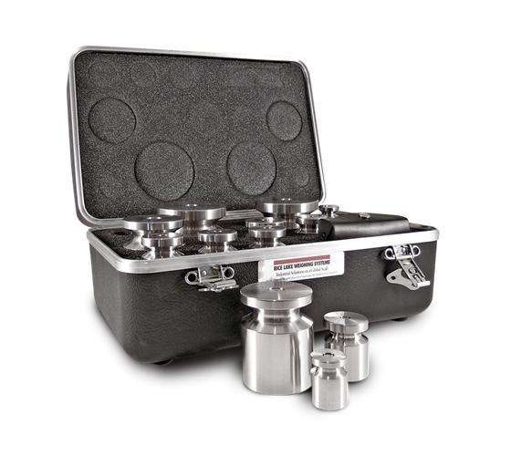
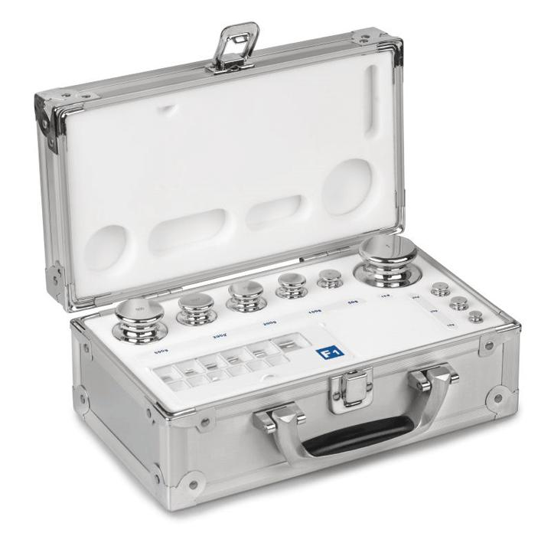
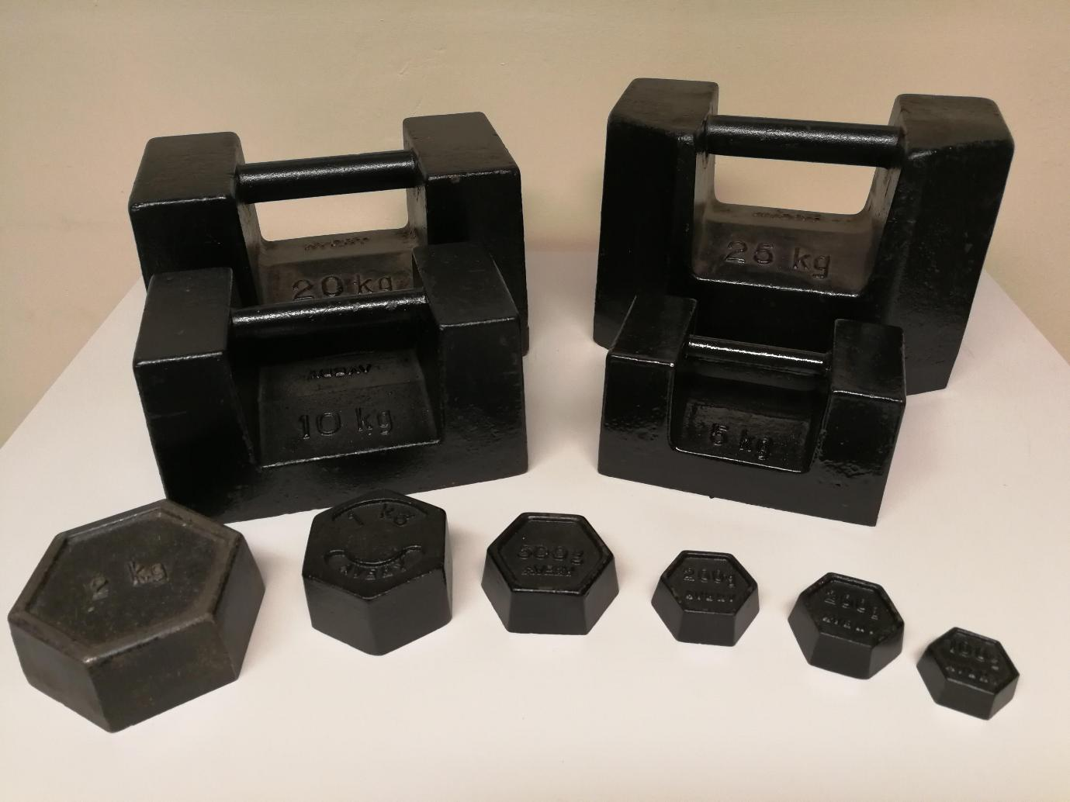
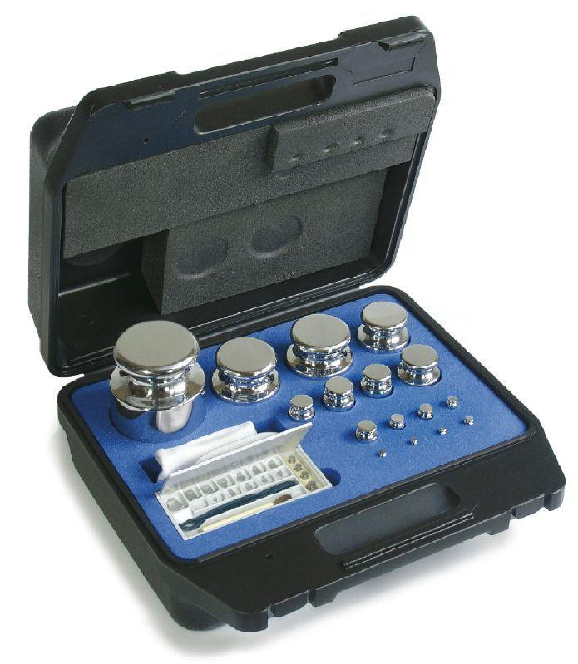
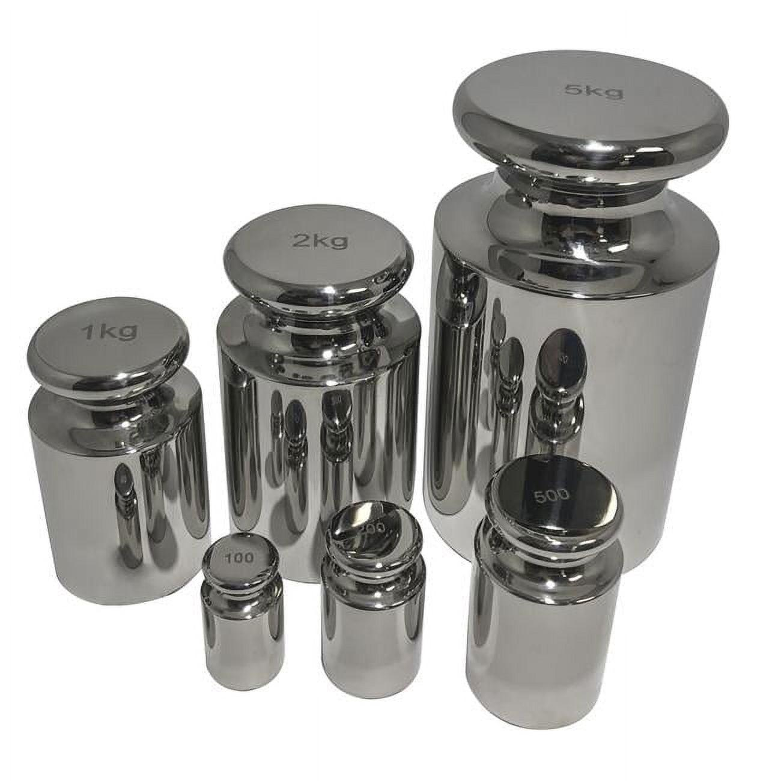
A Commercial Test Weight is a calibrated reference weight used to verify, test, and calibrate commercial weighing scales such as retail scales, platform scales, bench scales, truck scales, and industrial weighing systems. Unlike high-precision laboratory calibration weights, commercial test weights are designed for routine field verification and legal metrology.
Commercial test weights are commonly manufactured according to OIML R111 or equivalent national metrology standards.

Definition
# Source: AI Source: Provided by: [Data Path: Persons Table -> ID Column: 1, Name_En Column: Motasem Essam] -> From: [ChatGPT] on [7/17/2026]
A Commercial Test Weight is a standardized reference weight with a certified nominal mass used to verify the accuracy and calibration of commercial weighing equipment.

Purpose
# Source: AI Source: Provided by: [Data Path: Persons Table -> ID Column: 1, Name_En Column: Motasem Essam] -> From: [ChatGPT] on [7/17/2026]
Commercial test weights are used to:
- Verify commercial weighing scales.
- Calibrate industrial weighing systems.
- Perform routine scale inspections.
- Support legal metrology compliance.
- Maintain weighing accuracy in commercial transactions.

Principle of Operation
# Source: AI Source: Provided by: [Data Path: Persons Table -> ID Column: 1, Name_En Column: Motasem Essam] -> From: [ChatGPT] on [7/17/2026]
Commercial test weights provide a known reference mass.
The scale reading is compared with the certified value of the test weight.
Any deviation indicates the need for adjustment or recalibration.

Main Components
# Source: AI Source: Provided by: [Data Path: Persons Table -> ID Column: 1, Name_En Column: Motasem Essam] -> From: [ChatGPT] on [7/17/2026]

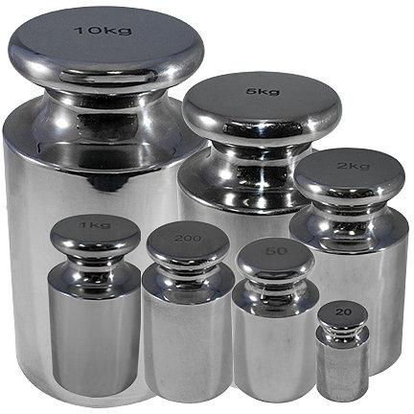
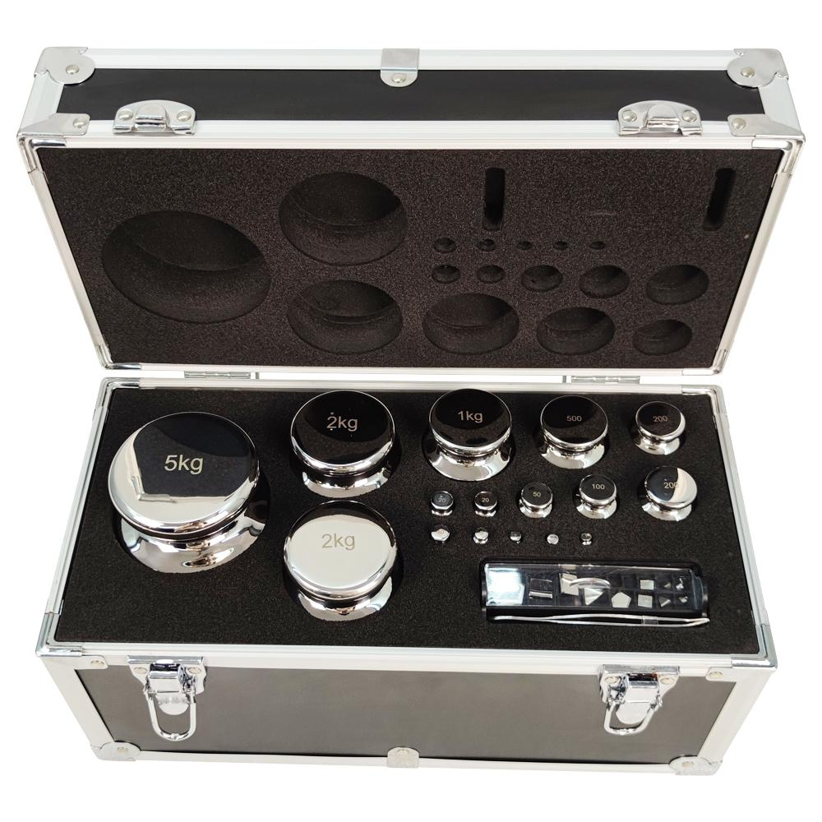
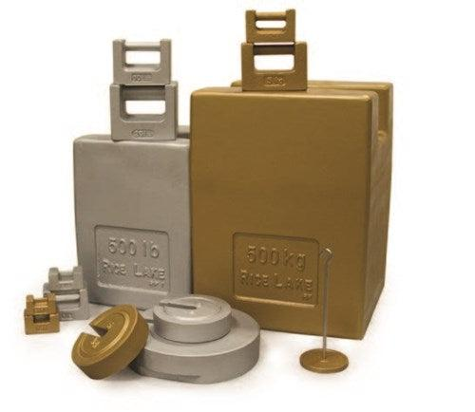
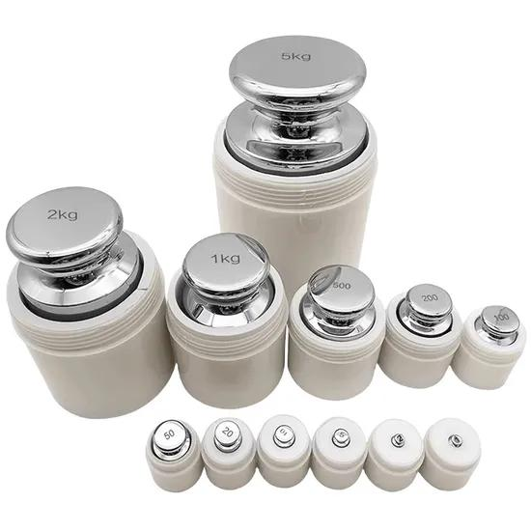
A commercial test weight typically consists of:
- Solid metal body
- Handle or lifting grip (large weights)
- Identification marking
- Protective coating (cast iron models)
- Calibration certificate (certified sets)

Types of Commercial Test Weights

1. Cast Iron Test Weights
# Source: AI Source: Provided by: [Data Path: Persons Table -> ID Column: 1, Name_En Column: Motasem Essam] -> From: [ChatGPT] on [7/17/2026]
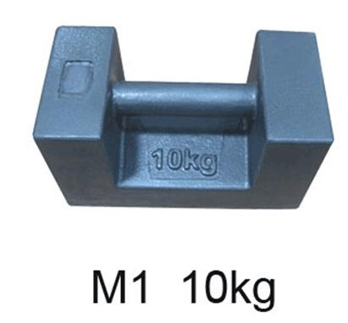
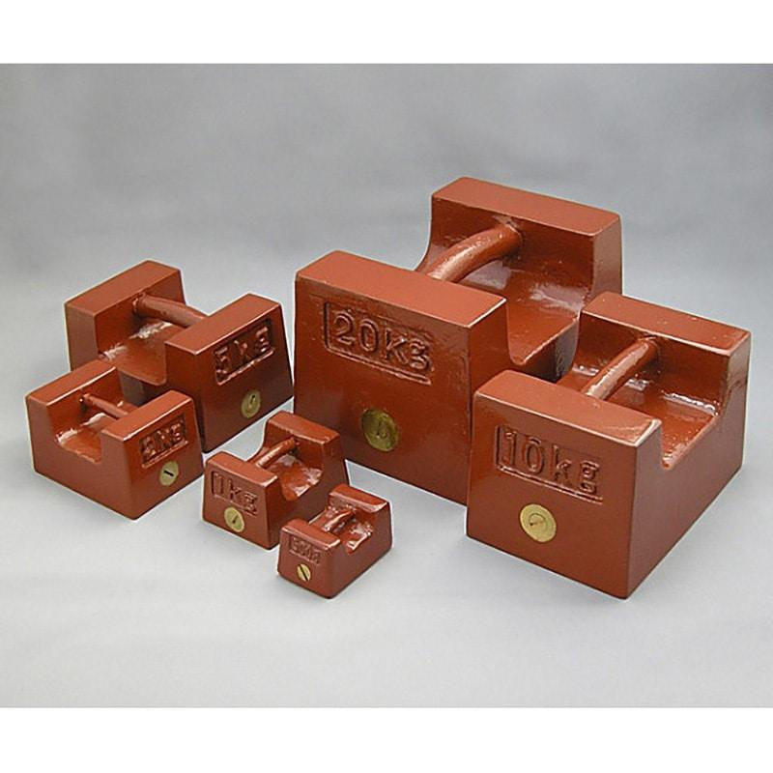
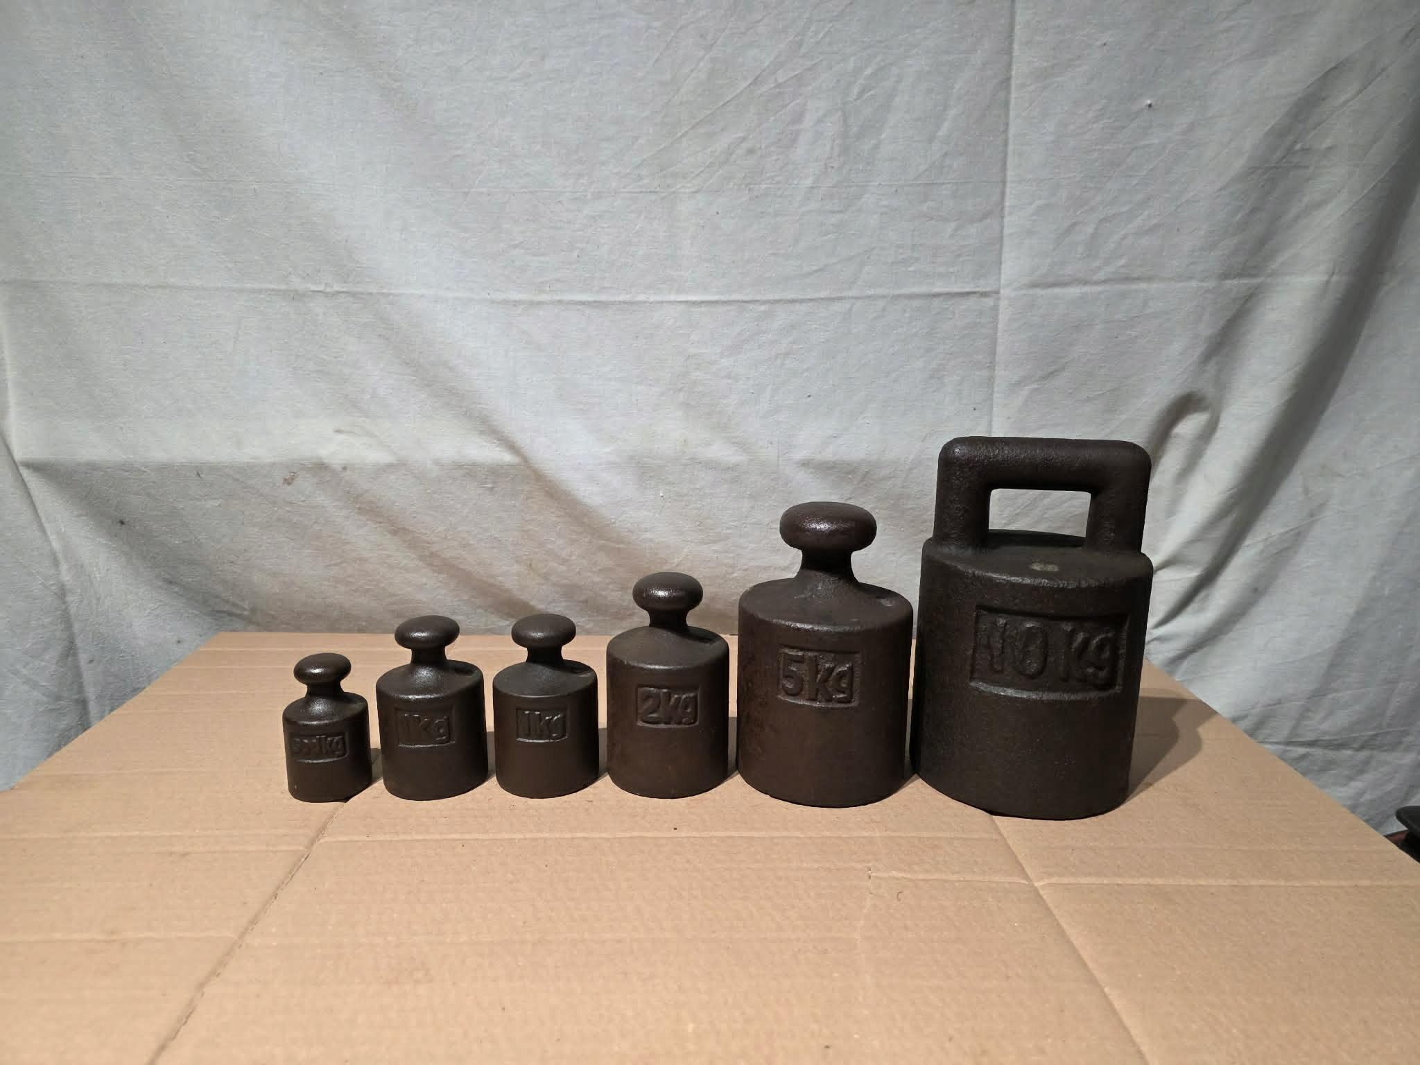
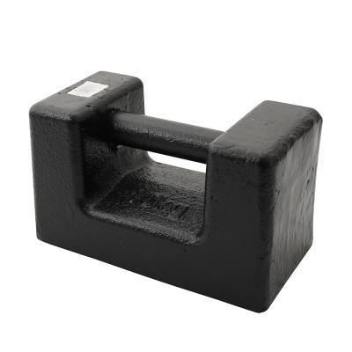
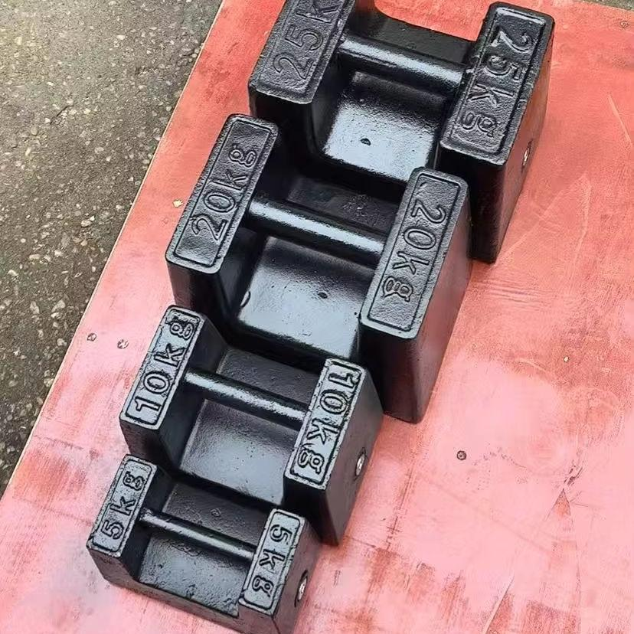

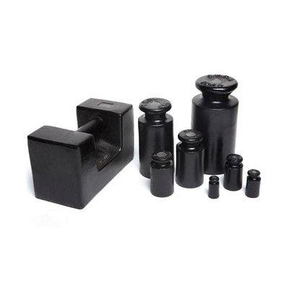
Description
Cast Iron Test Weights are rugged, heavy-duty calibration weights manufactured from cast iron and commonly coated with protective paint or epoxy. They are primarily used for calibrating commercial and industrial weighing equipment such as platform scales, floor scales, truck scales, and large industrial balances.
Features
- Made from durable cast iron
- Protective painted or epoxy-coated finish
- Available with lifting handles for larger sizes
- High mechanical strength
- Manufactured according to OIML M1, M2, or M3 accuracy classes
- Suitable for field calibration and legal metrology
Applications
- Commercial weighing scale verification
- Industrial platform scales
- Floor scales
- Truck scales (weighbridges)
- Warehouse weighing systems
- Logistics and freight industries
- Government inspection and legal metrology
- Routine calibration of heavy-duty weighing equipment

2. Stainless Steel Test Weights
# Source: AI Source: Provided by: [Data Path: Persons Table -> ID Column: 1, Name_En Column: Motasem Essam] -> From: [ChatGPT] on [7/17/2026]
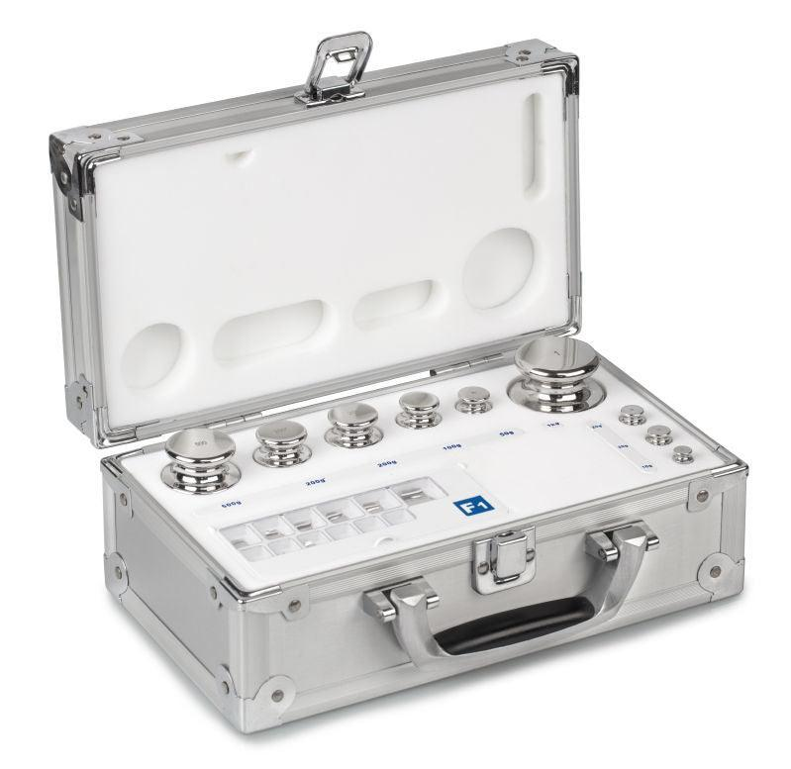

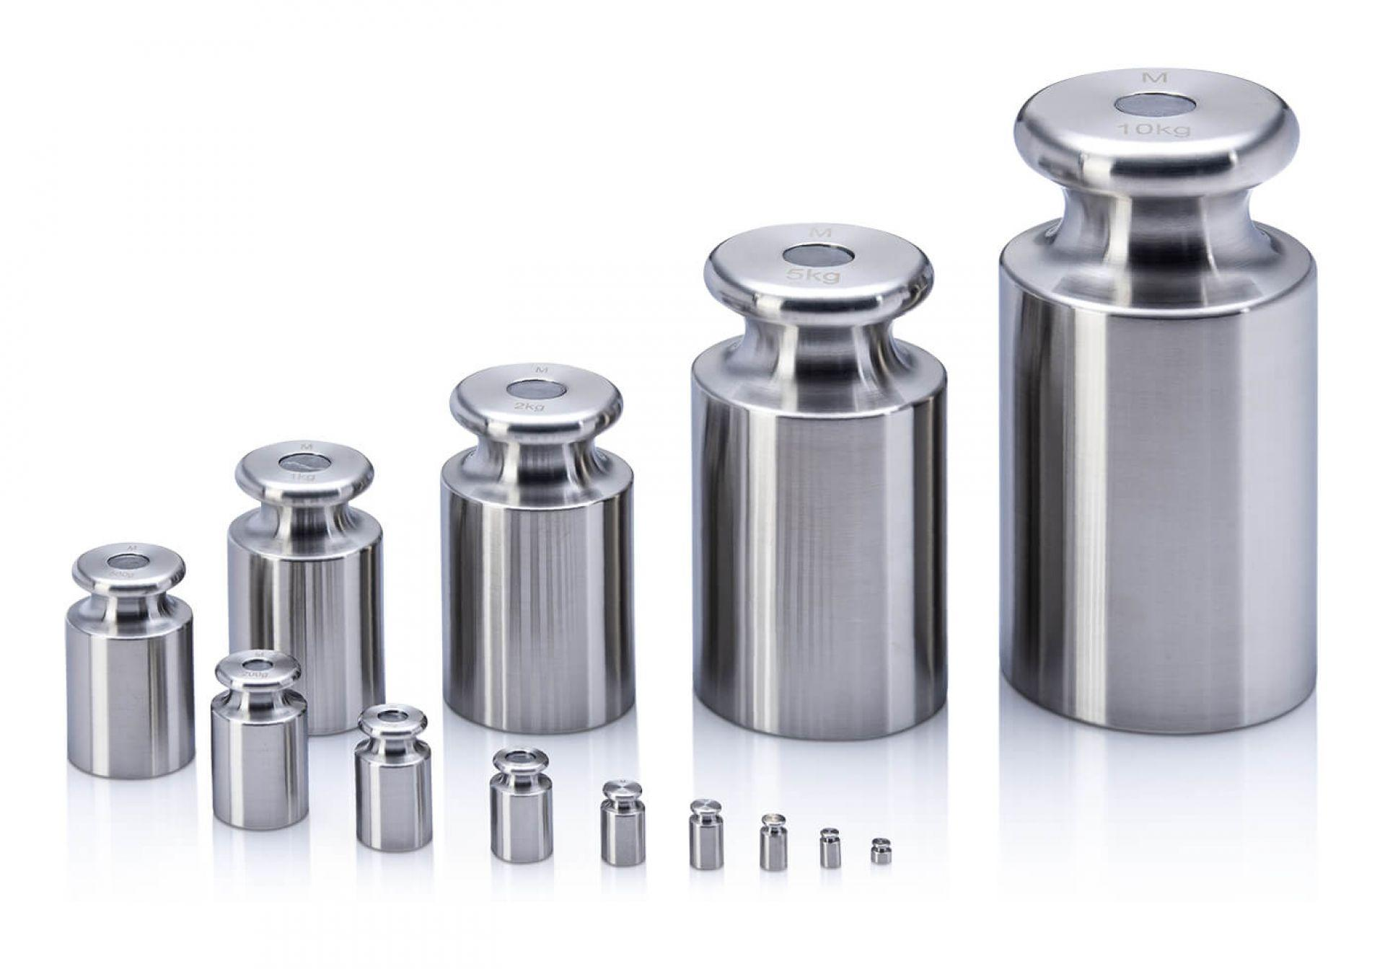
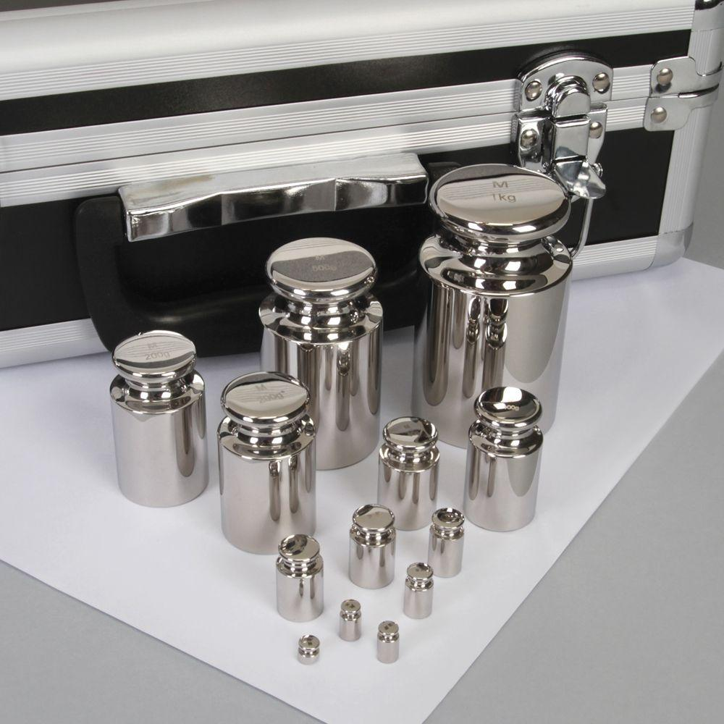
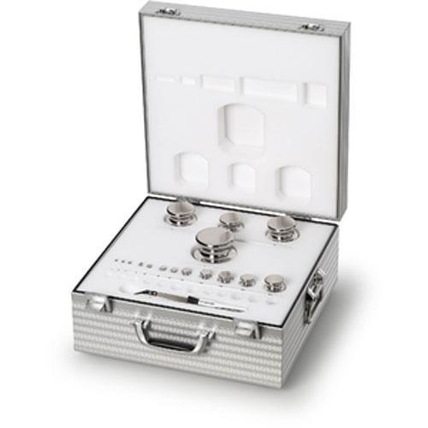
Description
Corrosion-resistant weights used where higher precision and cleanliness are required.
Applications
- Food industry
- Pharmaceutical industry
- Precision commercial scales

3. Cylindrical (Knob) Test Weights
# Source: AI Source: Provided by: [Data Path: Persons Table -> ID Column: 1, Name_En Column: Motasem Essam] -> From: [ChatGPT] on [7/17/2026]
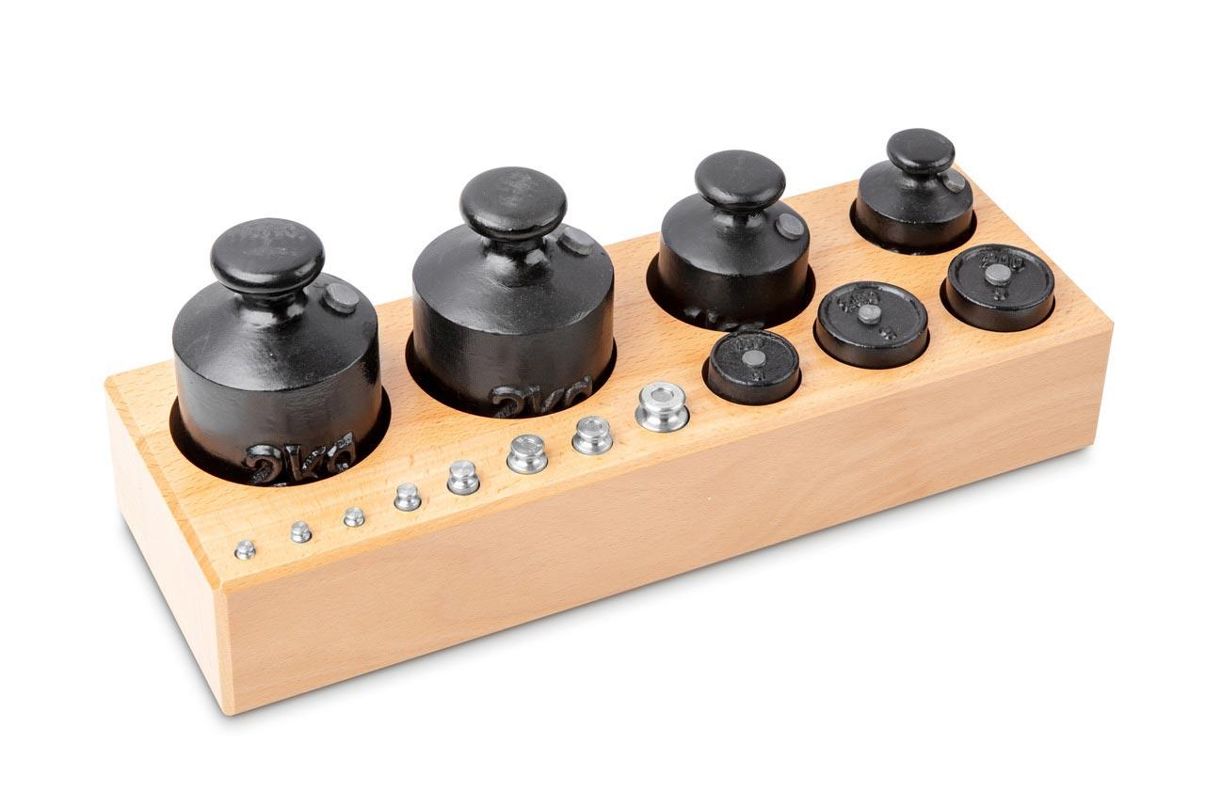
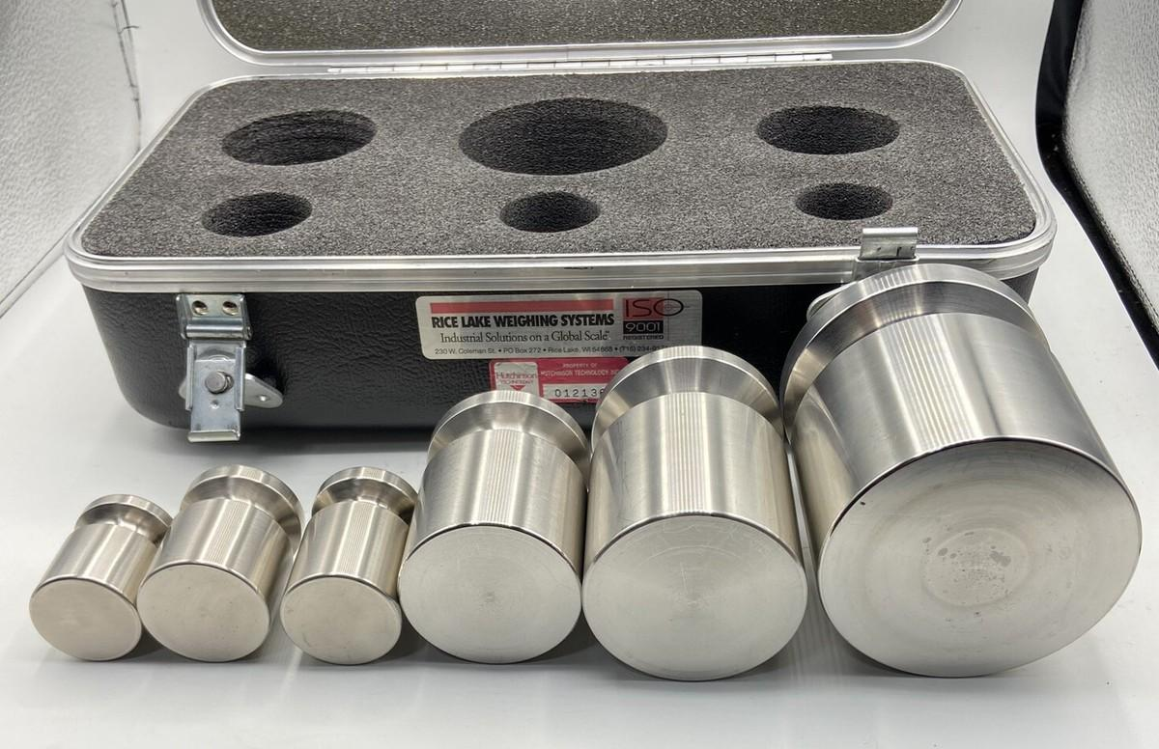

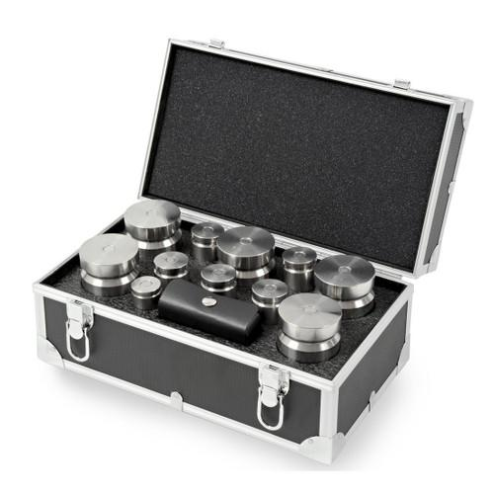
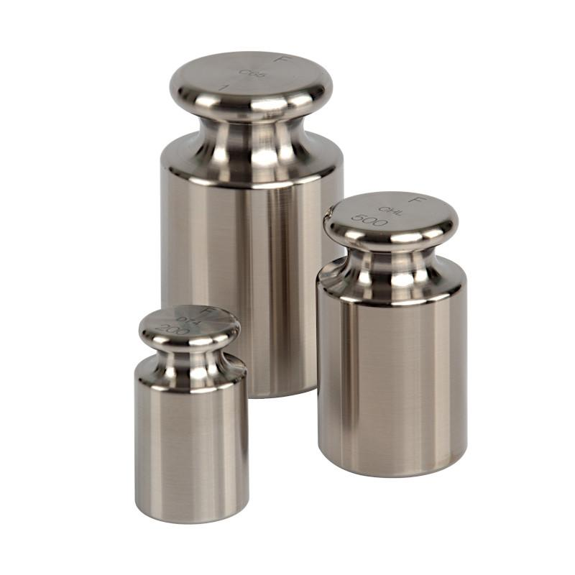
Description
Cylindrical weights with a lifting knob for convenient handling.
Applications
- Bench scales
- Platform balances
- Laboratory and commercial verification

4. Block Test Weights
# Source: AI Source: Provided by: [Data Path: Persons Table -> ID Column: 1, Name_En Column: Motasem Essam] -> From: [ChatGPT] on [7/17/2026]
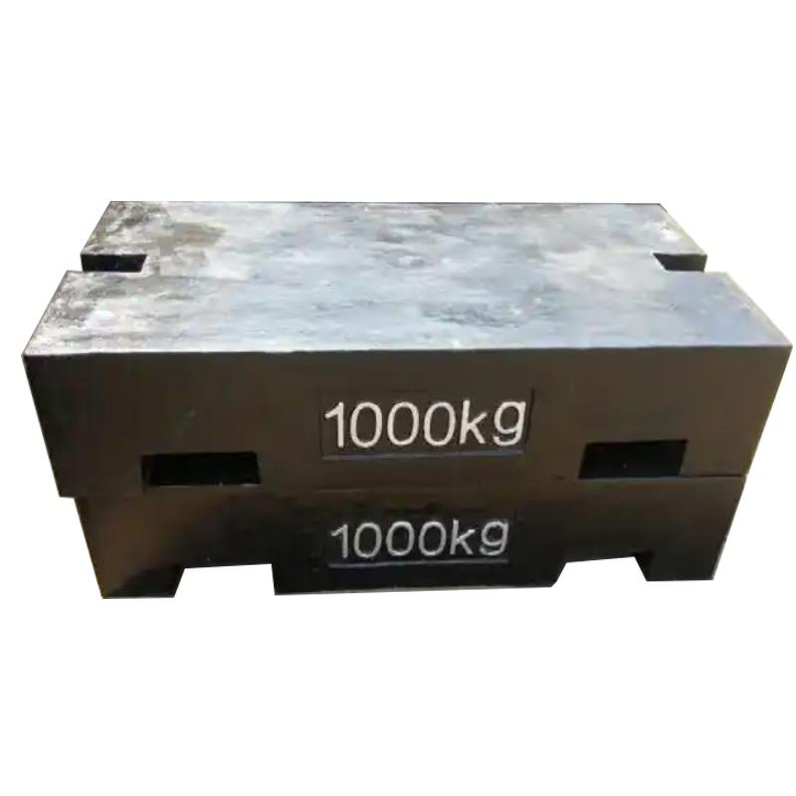
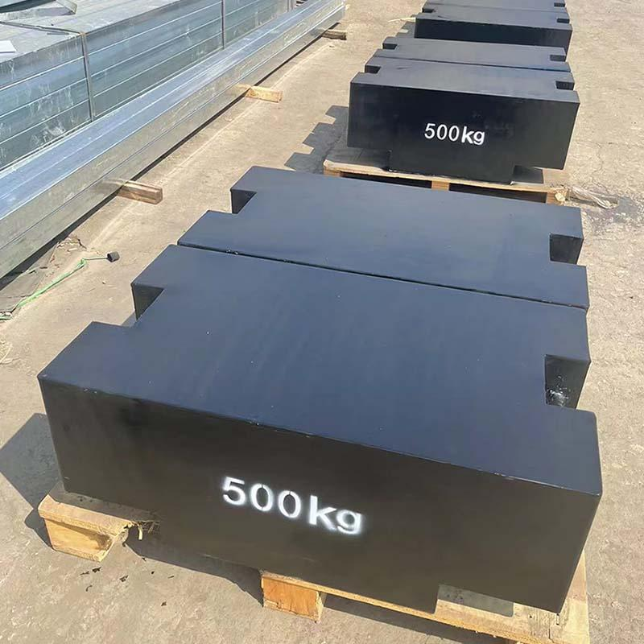
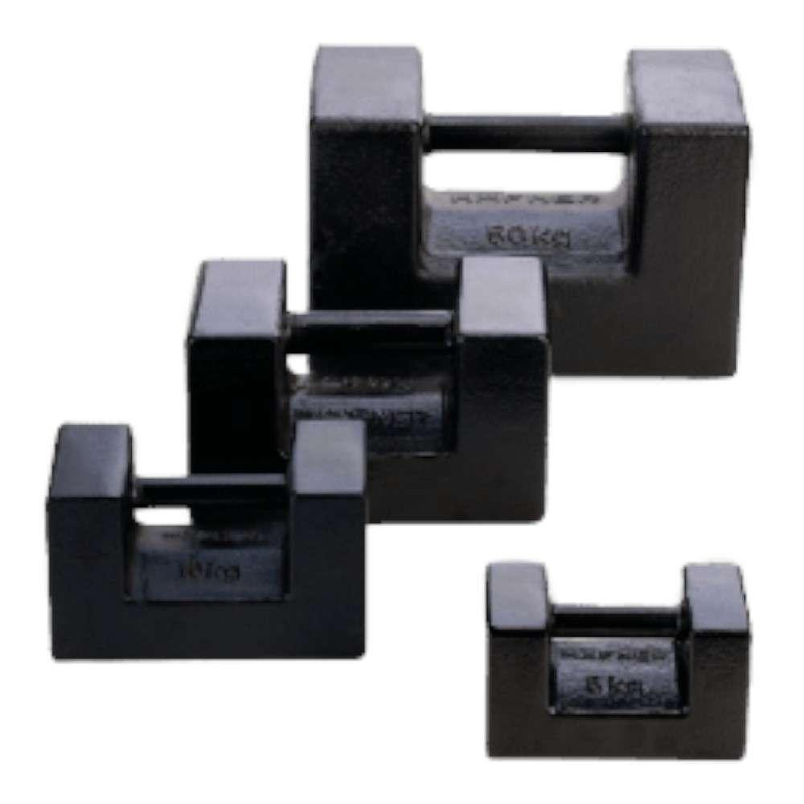
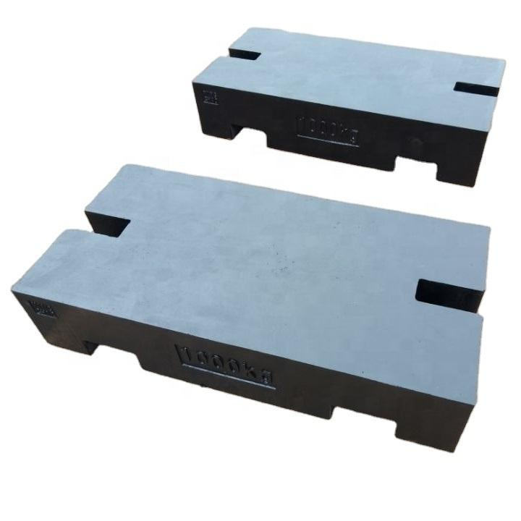
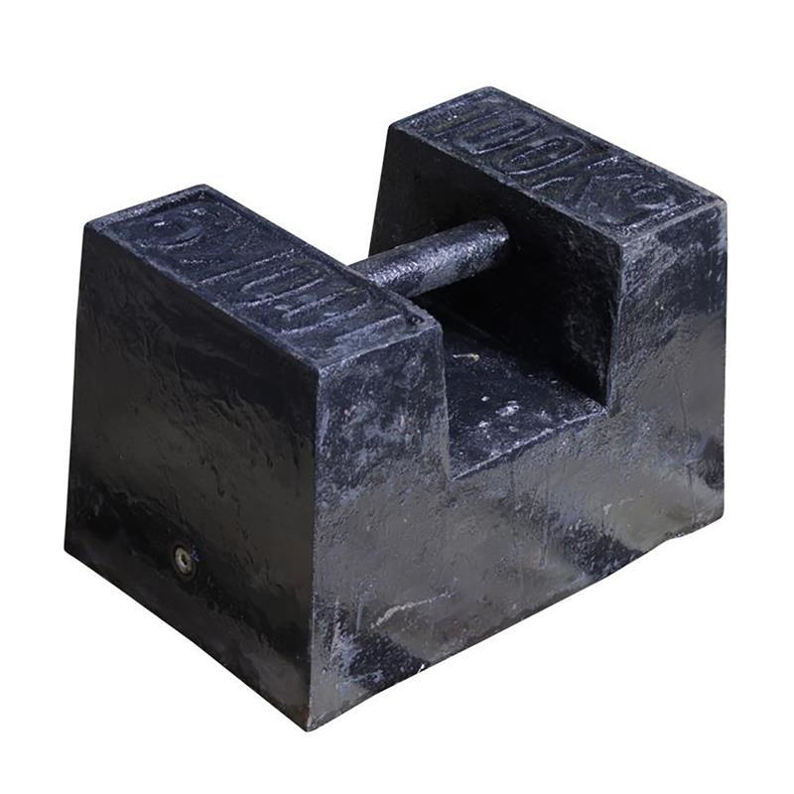
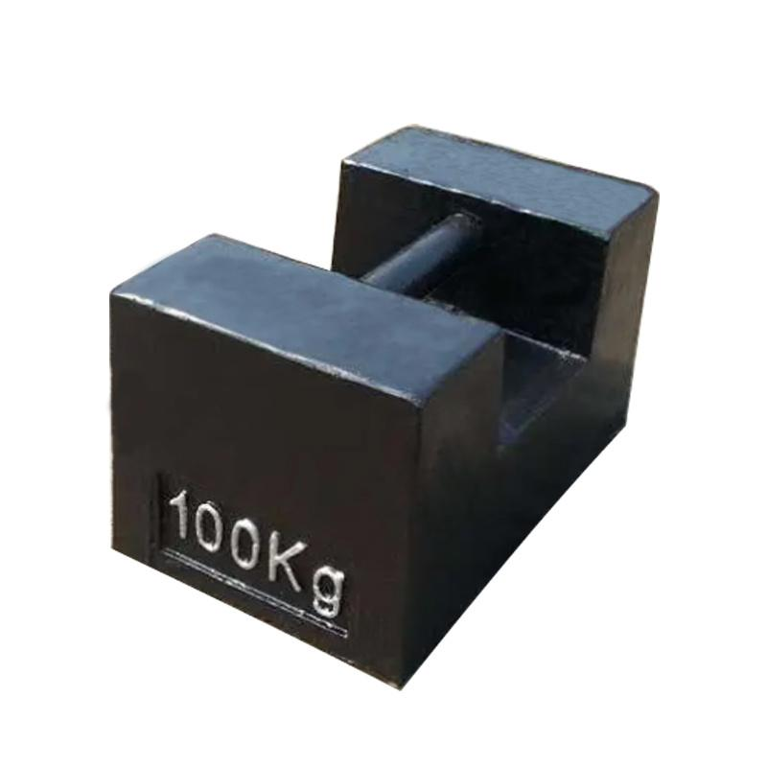
Description
Large rectangular weights designed for forklifts or cranes.
Applications
- Truck scales
- Crane scales
- Heavy industrial weighing

OIML Accuracy Classes
# Source: AI Source: Provided by: [Data Path: Persons Table -> ID Column: 1, Name_En Column: Motasem Essam] -> From: [ChatGPT] on [7/17/2026]
Commercial test weights are commonly available in:
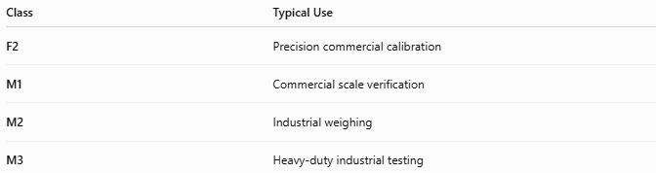
Class | Typical Use
F2 | Precision commercial calibration
M1 | Commercial scale verification
M2 | Industrial weighing
M3 | Heavy-duty industrial testing

Materials
# Source: AI Source: Provided by: [Data Path: Persons Table -> ID Column: 1, Name_En Column: Motasem Essam] -> From: [ChatGPT] on [7/17/2026]
Common materials include:
- Cast iron
- Stainless steel
- Nickel-plated steel

Measuring Units
# Source: AI Source: Provided by: [Data Path: Persons Table -> ID Column: 1, Name_En Column: Motasem Essam] -> From: [ChatGPT] on [7/17/2026]
Commercial test weights are manufactured in:
- Gram (g)
- Kilogram (kg)
- Ton (t)
- Pound (lb) (some regions)

Measuring Range
# Source: AI Source: Provided by: [Data Path: Persons Table -> ID Column: 1, Name_En Column: Motasem Essam] -> From: [ChatGPT] on [7/17/2026]
Commercial test weights are available in standardized mass values covering light commercial to heavy industrial applications.
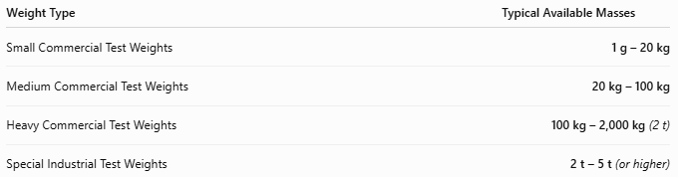
Weight Type | Typical Available Masses
Small Commercial Test Weights | 1 g – 20 kg
Medium Commercial Test Weights | 20 kg – 100 kg
Heavy Commercial Test Weights | 100 kg – 2,000 kg (2 t)
Special Industrial Test Weights | 2 t – 5 t (or higher)

Resolution
# Source: AI Source: Provided by: [Data Path: Persons Table -> ID Column: 1, Name_En Column: Motasem Essam] -> From: [ChatGPT] on [7/17/2026]
Commercial test weights do not display measurements, so they do not have a measurement resolution.
Instead, they are manufactured in standard nominal mass increments.
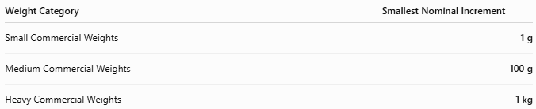
Weight Category | Smallest Nominal Increment
Small Commercial Weights | 1 g
Medium Commercial Weights | 100 g
Heavy Commercial Weights | 1 kg

Accuracy
# Source: AI Source: Provided by: [Data Path: Persons Table -> ID Column: 1, Name_En Column: Motasem Essam] -> From: [ChatGPT] on [7/17/2026]
Accuracy is determined by the OIML accuracy class, which specifies the maximum permissible error.
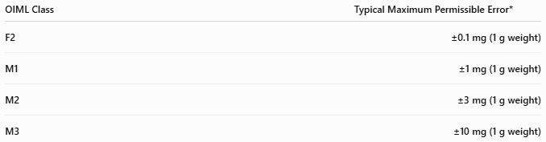
OIML Class | Typical Maximum Permissible Error*
F2 | ±0.1 mg (1 g weight)
M1 | ±1 mg (1 g weight)
M2 | ±3 mg (1 g weight)
M3 | ±10 mg (1 g weight)
*Maximum permissible error increases with the nominal mass according to OIML R111.
Notes
- M1 weights are the most commonly used for commercial scale verification.
- F2 weights provide higher accuracy for precision commercial applications.
- Larger industrial weights have larger permissible tolerances because of their higher nominal masses.
- Certified commercial test weights include calibration documentation that ensures traceability to national standards.

How to Use Commercial Test Weights
# Source: AI Source: Provided by: [Data Path: Persons Table -> ID Column: 1, Name_En Column: Motasem Essam] -> From: [ChatGPT] on [7/17/2026]
- Ensure the scale is level and zeroed.
- Place the certified test weight gently on the weighing platform.
- Compare the displayed value with the certified mass.
- Record any deviation.
- Recalibrate the scale if necessary.

Applications
# Source: AI Source: Provided by: [Data Path: Persons Table -> ID Column: 1, Name_En Column: Motasem Essam] -> From: [ChatGPT] on [7/17/2026]
Commercial test weights are used in:
- Retail stores
- Supermarkets
- Warehouses
- Logistics
- Industrial manufacturing
- Government inspection agencies
- Calibration service providers

Advantages
# Source: AI Source: Provided by: [Data Path: Persons Table -> ID Column: 1, Name_En Column: Motasem Essam] -> From: [ChatGPT] on [7/17/2026]
Commercial test weights:
- Provide reliable reference masses.
- Support legal trade compliance.
- Are durable and reusable.
- Require no electrical power.
- Allow rapid verification of commercial scales.

Limitations
# Source: AI Source: Provided by: [Data Path: Persons Table -> ID Column: 1, Name_En Column: Motasem Essam] -> From: [ChatGPT] on [7/17/2026]
Commercial test weights:
- Must be periodically recalibrated.
- Can be damaged by corrosion or impacts.
- Heavy weights require lifting equipment.
- Lower accuracy than laboratory E-class standards.

Sources of Error
# Source: AI Source: Provided by: [Data Path: Persons Table -> ID Column: 1, Name_En Column: Motasem Essam] -> From: [ChatGPT] on [7/17/2026]
Weight Errors
- Corrosion
- Surface contamination
- Physical damage
- Wear

User Errors
- Improper handling
- Incorrect placement on the scale
- Using weights outside their certification interval

Environmental Errors
- Dust
- Moisture
- Temperature changes
- Air buoyancy (for smaller weights)

Comparison with Other Mass Standards
# Source: AI Source: Provided by: [Data Path: Persons Table -> ID Column: 1, Name_En Column: Motasem Essam] -> From: [ChatGPT] on [7/17/2026]
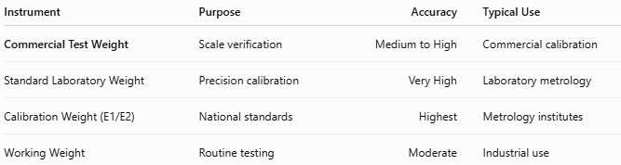
Instrument | Purpose | Accuracy | Typical Use
Commercial Test Weight | Scale verification | Medium to High | Commercial calibration
Standard Laboratory Weight | Precision calibration | Very High | Laboratory metrology
Calibration Weight (E1/E2) | National standards | Highest | Metrology institutes
Working Weight | Routine testing | Moderate | Industrial use

Care and Maintenance
# Source: AI Source: Provided by: [Data Path: Persons Table -> ID Column: 1, Name_En Column: Motasem Essam] -> From: [ChatGPT] on [7/17/2026]
To preserve accuracy:
- Store in protective cases or designated racks.
- Keep weights clean and dry.
- Handle with appropriate lifting equipment.
- Avoid dropping or impacting weights.
- Recalibrate at scheduled intervals.

Common Mistakes
# Source: AI Source: Provided by: [Data Path: Persons Table -> ID Column: 1, Name_En Column: Motasem Essam] -> From: [ChatGPT] on [7/17/2026]
- Using damaged weights.
- Mixing different OIML accuracy classes.
- Handling precision weights without gloves (for smaller masses).
- Using uncertified weights for legal verification.

Key Points
# Source: AI Source: Provided by: [Data Path: Persons Table -> ID Column: 1, Name_En Column: Motasem Essam] -> From: [ChatGPT] on [7/17/2026]
- A Commercial Test Weight is a reference mass, not a measuring instrument.
- It is used to verify and calibrate commercial weighing equipment.
- Common types:
  - Cast Iron Test Weights
  - Stainless Steel Test Weights
  - Cylindrical (Knob) Test Weights
  - Block Test Weights
- Common OIML classes:
  - F2
  - M1
  - M2
  - M3
- Widely used in retail, industry, logistics, and legal metrology.

Conclusion
# Source: AI Source: Provided by: [Data Path: Persons Table -> ID Column: 1, Name_En Column: Motasem Essam] -> From: [ChatGPT] on [7/17/2026]
A Commercial Test Weight is a standardized reference mass designed for the verification and calibration of commercial and industrial weighing systems. Built to recognized OIML standards and available in various materials, designs, and capacities, these weights play a vital role in ensuring accurate trade transactions, regulatory compliance, industrial quality control, and reliable scale performance.

